**ASSIGNMENT SUBMISSION COVER SHEET**

**Student Id: cse24-033**

**Student names: Prince Segokgo**

**Student email: cse24-033@thuto.bac.ac.bw**

**Cohort: cse24**

**Assignment title: The BANKING System**

**Date of submission: Friday 19 september**

**Programme of Study: BSC**

**Year of Study:2025**

**Intellectual property statement**

**By checking the box below, I certify that this assignment is my own work and is free from plagiarism. I understand that the assignment may be checked for plagiarism by electronic or other means and may be transferred and stored in a database for the purposes of data-matching to help detect plagiarism. The assignment has not previously been submitted for assessment in any other unit or to any other institution.**

**I have read and understood the Botswana Accountancy College plagiarism guidelines policy.**

* **Agree                                                              19/09/2025**

**Signature……………p.segokgo………………………. Date……………19/09/2025…………………………….**

**Banking System Requirements**

**Interviewer:** Prince segokgo  
**Interviewee:** Themba Moeng  
**Date:** Wednesday, 17 September 2025

**General Banking System Questions**

**1.** What are the main services the bank should provide to customers in this system?

The system should allow customers to open accounts, deposit funds, withdraw money, check balances, and view transaction history.

**2** .What types of accounts should the system support?

The system must support three account types: Savings Account, Investment Account, and Cheque Account.

**3.** Can one customer hold multiple accounts?  
 Yes, a single customer should be able to open and manage multiple accounts of different types.

**Functional Requirements**

**4.** How should customers open a new account? What details are required?  
A customer must provide their personal details such as first name, surname, address, and contact information.

**5.** Should the system support customer registration and login?  
 Yes, there should be a registration process where customers create an account with login credentials. They should then be able to log in securely.

**6.** What operations should be available on accounts?  
 Customers should be able to deposit, withdraw, and transfer funds between their accounts. They should also be able to check balances and view transaction history.

**Non-Functional Requirements**

**8.**What level of security should the system have?  
 The system should require login authentication with a secure password. Data should be validated to prevent fraud or unauthorized access.

**10.**Do you expect the system to scale and handle many users?  
 Yes, it should be designed to handle multiple customers and accounts without performance issues.

. **Structural UML Modelling**

**Use Case Diagram**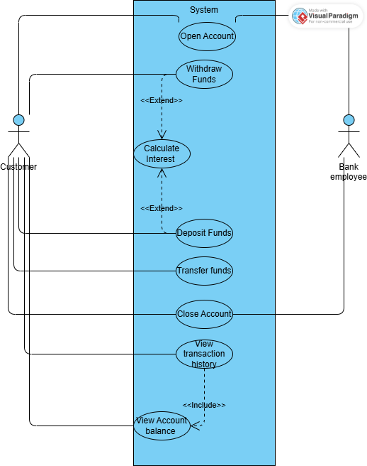

**Class diagram**

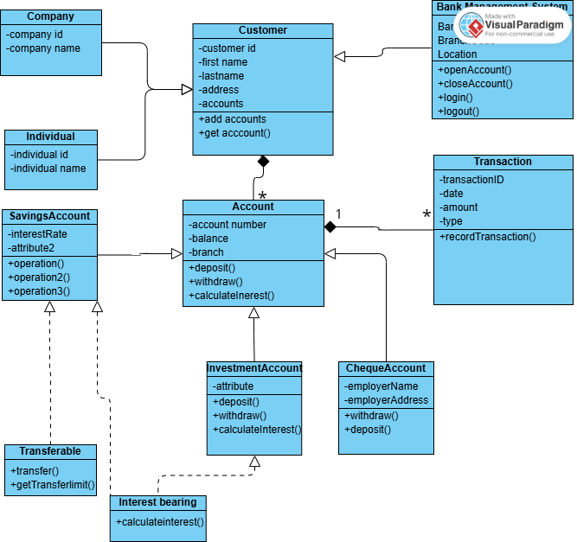

**Behavioural UML Modelling**

**Sequence Diagrams**

**

**Deposit**

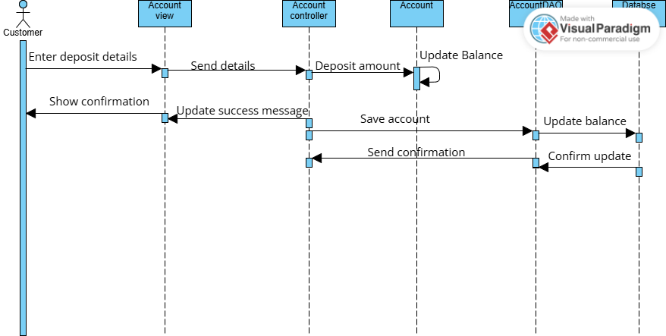

**State Diagram**

**Meeting appendix**

[**Recap: Room 1 Wednesday, 17 September | Meeting | Microsoft Teams**](https://teams.microsoft.com/l/meetingrecap?driveId=b%21_EvOa1sks0iIYDJxiVXe6hfVUdCsE-BFqNJUN0MODZ7jEPuQy5IFQLY7WUGf_kN4&driveItemId=01MKMK6WK4WTSC3ZTHO5AJMJM7B2P7DIKZ&sitePath=https%3A%2F%2Fmybac-my.sharepoint.com%2F%3Av%3A%2Fg%2Fpersonal%2Fthembam_bac_ac_bw%2FEVy05C3mZ3dAliWfDp_xoVkB8YiMD1AN5BFuKvxb2fGDPw&fileUrl=https%3A%2F%2Fmybac-my.sharepoint.com%2Fpersonal%2Fthembam_bac_ac_bw%2FDocuments%2FRecordings%2FRoom%25201-20250917_182128-Meeting%2520Recording.mp4%3Fweb%3D1&threadId=19%3Ameeting_MWJkMjQ5YWEtYzUwZS00NWQyLWFiMTktMzdkY2YyN2VmOWVl%40thread.v2&organizerId=b4687eda-1647-40e4-9eee-73ac3484a4fa&tenantId=ee292977-7b58-4df4-8138-50d0de7d28d8&callId=50594a25-8656-44da-a4dc-f6a1fd5517a5&threadType=Meeting&meetingType=Scheduled&subType=RecapSharingLink_RecapCore)